The cause of annual food shortage among the major Jur- bel community of Mvolo

By: Maku Denis Eleu

Introduction

Mvolo is located in North West of newly formed Amadi state bordering Lakes states to the North and Maridi state to the West.

It is inhabited by Jur-Bel Ethnic group with population of 48,000 (census, 2008)

The Jur major livelihood revolves around sedentary crop farming.

People here mainly lives through agriculture with supplementary income from fishing, beekeeping and wild crafting for shea (Vitelaria paradoxa L.) fruits and oil.

The crop cultivated by the Jur community is mainly sorghum. The common one a long term variety of the genus *sorghum bi color L.*(red kernel open drooped down panicle). Also, the community inter-cropped sesame (*sesame indicum L.)* and to a lesser amount, green gram or mung bean (vigna radiate L.)and groundnut (Arachis hypogea L.)among sorghum stands. The cropping season start late April to late October (IRNA report, 2015).

The long term sorghum, most desired crop by the community stay in the field until early December. After harvesting in December, the food stock for most Mvolo households last until early April, only in 3 months after harvest.

Mvolo community faced sever food shortage annually from April to July. The situation will always improve after August when oil crop sesame and groundnut and pulse crop green gram are ready.

This scenario is always misattributed to factors such as dry spell, conflict lack of access to market etc.

In 2015, Mvolo was hit by a severe food shortage that claim the life of 10 people (IRNA report, 2015), the cause was attributed to disruption of agriculture activities by mass displacement after conflict with neighboring Yirol community. The report also blame delayed rain as well as the use of long term sorghum varieties that last 6 months in the field.

The worse one was between April and August 2017. Mvolo multi-cluster rapid assessment (2017) reported that, Mvolo is hit by worse ever hunger that claim life of 74 people in what they term as food insecurity and malnutrition caused by inadequate food intake based on assessment results.

The report has to some extend blamed the cause of hunger to persistent dry spell, use of late mature sorghum variety as well as conflict that displaced people leaving behind their livelihood asset un attended

2. Literature Review

2.1. Population demography for Mvolo

The population size of Mvolo County as per South Sudan census (2008) stand at 48,000. However, the population projection of South Sudan between 2015 and 2020 is estimated the one for greater Mvolo at 59,270 (Baseline survey for CTLRI, 2015). The detailed population per each location of greater Mvolo is shown below (Table 1.Population projection for greater Mvolo 2015-2020)

|  |  |  |  |
| --- | --- | --- | --- |
| Table 1.Population projection for greater Mvolo 2015-2020 | | | |
| Locations | Male | Female | Total Population |
| Kokoradditional | 3216 | 3067 | 6283 |
| Bagori | 3125 | 2980 | 6105 |
| Lessi | 2730 | 2604 | 5334 |
| Bahr El Grindi | 5309 | 5063 | 10372 |
| Mvolo | 6492 | 6192 | 12684 |
| Dari | 3064 | 2922 | 5986 |
| Yeri | 6401 | 6105 | 12506 |
| Total | 30337 | 28933 | 59270 |

Source: Baseline survey for CTLRI, 2015

2.2. Food security and livelihood in Mvolo

2.2.1. Livelihood of the Jur community of Mvolo

Livelihood is different ways in which people makes living and comprises: capability, assets, activities and strategies pursued by households and individuals for means of living (Baseline survey for CTLRI, 2015).

The Jur community of Mvolo are agrarian and their livelihood revolved mainly around crop production that account for 76% of the total livelihood with the other remaining 24% being attributed to off farm activities such as fishing, bee keeping, casual labor, employment and relief (Baseline survey for CTLRI,2015). The detailed of livelihood source is shown below (Table 2. Livelihood source for the Jur community of Mvolo)

Table 2: Households livelihood source among Jur community

|  |  |
| --- | --- |
| Household livelihood source | Percentage |
| Crop production | 76% |
| Casual labor | 16.4% |
| Employment | 2.1% |
| Business | 4.1% |
| Fishing | 0.7% |
| Relief | 0.7& |
| Total | 100 |

Source. Baseline survey for CTLRI, 2015

2.3. Crop production in Mvolo

Crop production is the main land use practices and predominantly the source of livelihood. Land ownership average 3.9 feddan. 3.1 of this(78.2%) goes to cultivation annually by the 76% of the total population.Only 2.1% of the community do not involved in crop production (Baseline survey for CTLRI, 2015).

The crop grown are sorghum which account the largest portion of crop produced followed by sesame from the table below (Table 4. Major crop cultivated by the Jur community of Mvolo). The agriculture here is rain-fed.

Table 4. Type of crop cultivated by the Jur community of Mvolo

|  |  |
| --- | --- |
| Crop type | Percentage |
| Sorghum | 140 |
| Sesame | 103 |
| Groundnut | 85 |
| Green gram | 1 |
| Maize | 13 |
| Common bean | 12 |
| Millet | 2 |
| Cassava | 1 |

Source: CTLRI baseline survey, 2015

Large proportion of house could note decline in productivity annually. On average, a house could harvest 16.2 bags of 50 kg from sorghum groundnut, sesame, maize and bean combine from the expected 19.5 bags of 50 kg. Up to 7 bags (40%) is sold and only 11.2 bags of 50kg (60%) is consumed (CTLRI baseline survey, 2015).

The community attributed the cause of low productivity to prolonged drought and conflict (IRNA report, 2015, Mvolo multi-cluster rapid assessment, 2017, Baseline survey for CTLRI, 2015) and soil fertility, rodent and pest (Baseline survey for CTLRI, 2015)

2.2.2. Food security and feeding regime of the Jur community of Mvolo

Household food security is calculates while considering the number of months the store food would last, and also based on the number of months of the hunger gaps (CTLRI base line survey, 2015). Hunger gap commenced as earlier as December through June and July. 47.1% will have exhausted their granaries before next harvest and 44.9% in 3 months after harvest as shown below (Table 5. Duration the food stock last after harvest)

Table 5. Duration the food stock last after harvest

|  |  |
| --- | --- |
| Number of months after harvest | Percentage households that exhausted store food |
| 3 months after harvest | 44.9% |
| 4 to 7 months after harvest | 47.1% |
| 8 months after harvest | 8.1% |

Source: CTLRI baseline survey, 2015

2.2.3. Crop maturity period

The crop cultivated by the Jur community of Mvolo are pre dominantly late mature sorghum varieties Nyondok, Nyarengo and Bari that last 5 months in the field and Deri which last 7 months. The funny thing is, most of this crop are planted very late after rain-onset. The other crop known to the local are sesame, cassava, bean, green gram and pumpkin (IRNA report, 2015).The table below shows the crop planted and the duration it take for the crop to mature

Table 6. Crop maturity period for cultivated crop in Mvolo

|  |  |  |  |
| --- | --- | --- | --- |
| Crop type | Planting month | Harvest month | Period crop last in the field |
| Okra | April/May | June | 2 or 3 months |
| Leli | April/May | July/Aug. | 3 months |
| Sesame | April/May | Sept./Oct. | 4 or 5 months |
| Bean/green gram | May/June | Oct. | 3 or 4 months |
| Nyondok | April/May | Sept./Oct | 5 or 6 months |
| Nyarengo | June/July | January | 6 or 7 months |
| Bari | July/Aug. | January | 6 months |
| Deri | May | December | 7 months |

Source: IRNA report, 2015

The below figure shows four of the five local sorghum varieties know to Mvolo people

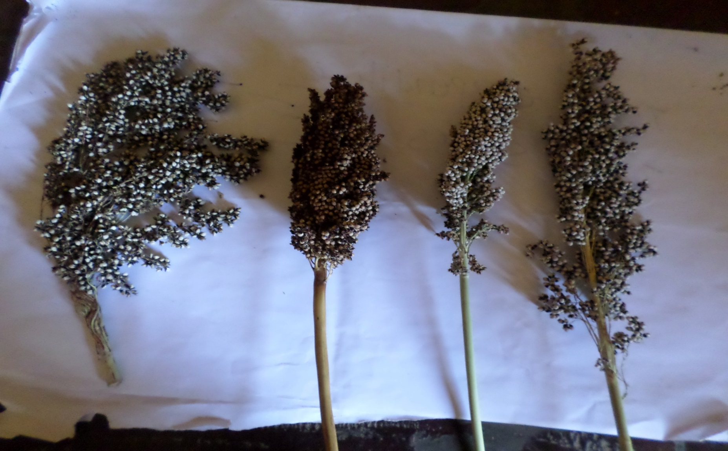

Local name: Nyondok

Local name: Leli

Local name: Nyarengo

Local name: Deri

Figure 1: Local sorghum varieties cultivated by the Jur of Mvolo (NPA collection, 2018)

Mvolo have the poorest food security among its neighbors. On the number of meals consume a day, there is rarely a household that consume 3 meals a day. According to CTLRI baseline survey report (2015), only 22.1% eat lunch a day, 20.6% super and 42.6% both lunch and super. No household were found to take 3 meal aday, a situation that always lead to weak and malnourish household whose members are prone to disease attack (CTLRI baseline survey, 2015)

3. Objective

Main aim of this work is to assess the real cause of annual food shortage among the Jur-bel community of Mvolo

Specific objective

1. Collect early mature sorghum producing household data
2. Collect late mature sorghum producing households data
3. Assess the percentage households producing early mature sorghum
4. Compare the period early mature and late mature household producers food stock last
5. Compare the livelihood status between late mature and early mature households
6. Assess population size who consume sorghum as wet meal
7. Assess the population size of household who consume their sorghum produces as fresh meal

Research questions

1. Are there farm household involve in production of early mature sorghum variety among Mvolo community?
2. What percentage of Mvolo community grow early mature sorghum varieties?
3. Is there difference in period household food stock last between households who involve in early mature sorghum varieties and those who grow long term sorghum varieties?
4. Is there any difference in livelihood between early mature sorghum crop growers and long term sorghum growers nutritionally?
5. Are there farm households who use sorghum as wet meal?
6. What percentage use sorghum food as wet meal as compare to fresh meal?
7. Is there any difference health wise between wet meal consumers and fresh meal consumers?
8. What perception do community have toward adoption of early mature crop?

4) Material and Method

4.1) Study area

Study will be conducted in greater Mvolo. The study will covered 4 sampling locations: Yeri County, Bar El grindi County, Mvolo County and Kokori Payam refer to Mvolo map below (Figure1: Map of Mvolo)

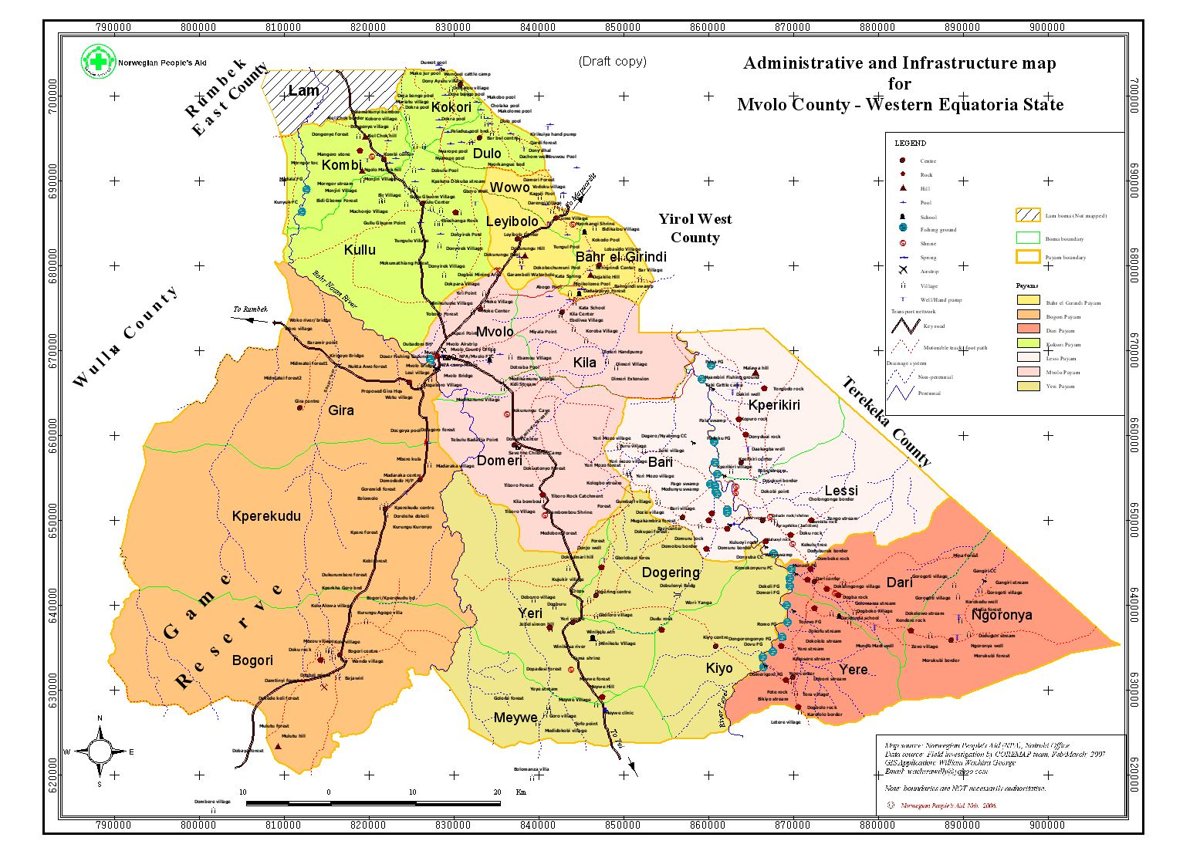

Figure 2: Map of greater Mvolo (NPA, 2010)

4.2. Study design

This study will use descriptive study design which involve both qualitative and quantitative approaches. The research will employed observation, case study and survey methods.

4.3 Sampling technique

Multi- stage sampling technique will be employ to sample 200 households from 4 main locations of Yeri, Mvolo, Bar El grindi and Kokori. In each main location, up to 50 households will be randomly selected from the community for various information.

4.4. Data collection technique

This study will employ various technique to gather needed informations, this includes focus group discussion (FGD), household questionnaires and observation

4.5. Data analysis

Collected data will be analyzed using SPSS version 19 descriptive statistic for percentage different, mean different and frequent count

5. Expected outcome and contribution of this work to NPA current and future intervention

High poverty is being observed among Jur-bel community of Mvolo, the cause are being assumed by many UN/NGOs who attempt to address the problem. The research will determine the real cause of poverty which NPA will use as an evident when planning for the area and also to convince the donor about the real issues on ground

6. Time schedule and budgeting

|  |  |  |  |  |  |  |  |
| --- | --- | --- | --- | --- | --- | --- | --- |
| Activities | Budget | 2018 | | 2019 | | |  |
| Nov. 2018 | Dec. 2018 | Jan.2019 | Feb.2019 | Mar.2019 |  |
| Literature review (contextual analysis of the cause from various work, framing the objective, research methodology | - |  |  |  |  |  |  |
| Presenting the idea to NPA and the need for it including making Mvolo community aware of the ongoing work | 10,000 SSP |  |  |  |  |  |  |
| Designing data collection tools | 5,000 SSP |  |  |  |  |  |  |
| Recruitment of data collection enumerators, orientation and data collection | 20,000 SSP |  |  |  |  |  |  |
| Data analysis and presentation to NPA for possible comment | 10,000 |  |  |  |  |  |  |
| Final write-up and submission for review | 5,000 |  |  |  |  |  |  |
| Presentation |  |  |  |  |  |  |  |
| Total amount of money | 50,000 |  |  |  |  |  |  |

Reference

Coordinated assessment. 2015. Mvolo inter-agent rapid assessment IRNA report August, 2015 Available at <http://southsudan.humanitarianresponse.info/>

Acacia consultant. 2015. Baseline report for conflict transformation through livelihood recovery project available here [**www.acaciaconsultants.org**](http://www.acaciaconsultants.org) **November, 2015**

**Coordinated assessment. 2017. Mvolo multi-cluster rapid assessment report, August, 2015. Available at** <http://southsudan.humanitarianresponse.info/>